TBPI Annenberg School for Communication Presentation

Theme
Theme to ensure that the presentation is interactive.
In this presentation, we will guide the audience through the Black Policy Institute's decision-making process, using the "Touching the Chair" exercise as a metaphor. We'll explore how BPI identifies key issues, collects, and analyses data, engages with the community, and formulates strategies. By examining the touch points of decision-making—from initial contact, through research, strategic planning, implementation, and evaluation—we'll illustrate our approach to addressing community issues. The session includes an interactive exercise to demonstrate these concepts in action, followed by a Q&A to address your questions and insights.

PRESENTATION

Slide 1-5: Introduction and Contents of the presentation
Explain the theme of the presentation.
In this presentation, we will guide the audience through the Black Policy Institute's decision-making process, using the "Touching the Chair" exercise as a metaphor. We'll explore how BPI identifies key issues, collects, and analyses data, engages with the community, and formulates strategies. By examining the touch points of decision-making—from initial contact, through research, strategic planning, implementation, and evaluation—we'll illustrate our approach to addressing community issues. The session includes an interactive exercise to demonstrate these concepts in action, followed by a Q&A to address your questions and insights.

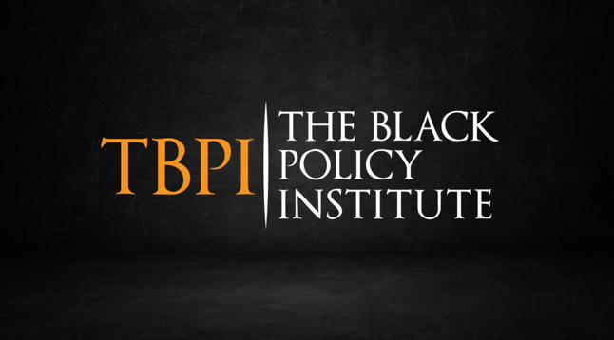 | 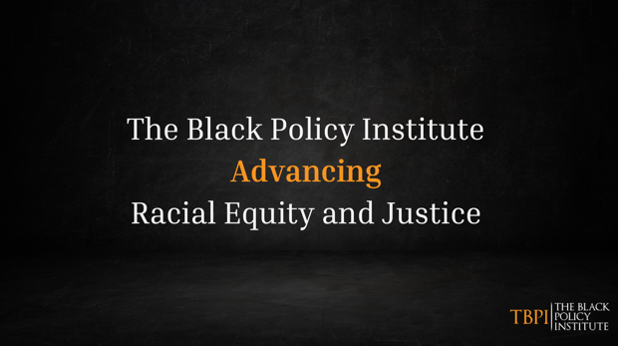
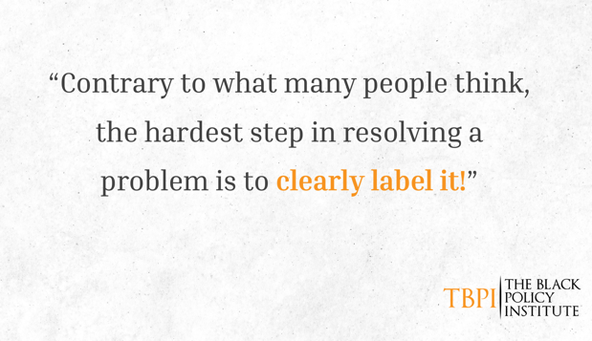 | 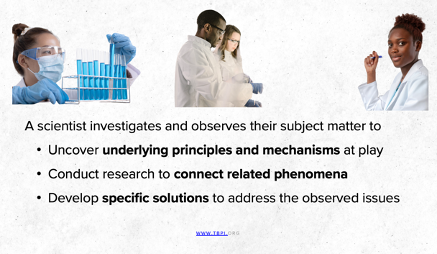

Introduction of the Elephant to be discussed later during question time.

Slide 6/7: Touching the Chair
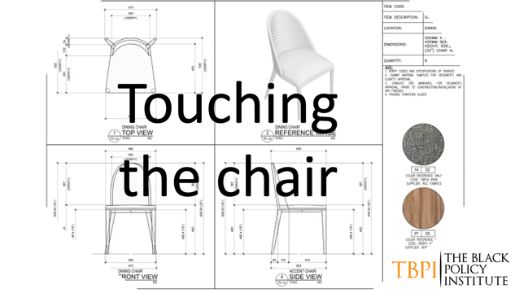
Here's a quick outline for the workshop:
Workshop Title: Touching the Chair: Understanding Objectives and the Function of Race
In the workshop "Touching the Chair: Understanding Objectives and the Function of Race," participants embark on a journey of introspection and inquiry. Through the simple act of attempting to touch a chair, they are confronted with the profound complexity of setting core objectives. As they dissect the chair's various components—the arm, the leg, the seat, the back—they come to realize that while each part contributes to the chair's function, none alone embodies its entirety. This metaphor serves as a poignant reminder of the nuanced nature of objectives, urging participants to approach their goals with a comprehensive understanding of all their constituent parts. Moreover, the workshop delves into the intricate function of race in society, challenging participants to critically examine its impact on identities, interactions, and societal structures. By engaging in this exploration, participants emerge with a heightened awareness of the multifaceted dynamics at play, equipped to navigate the complexities of objective-setting and racial dynamics with greater insight and sensitivity.

1. Introduction
- Briefly introduce the workshop's concept: touching the chair as a metaphor for understanding objectives and the function of race.
2. Activity 1: Touching the Chair
- Ask participants to attempt to touch a chair placed in the room.
- Explain that it's impossible to touch the entire chair at once because it consists of multiple parts.
- Break down the parts of the chair:
- Arm
- Leg
- Seat
- Back
- Emphasize that while each part contributes to the chair's function, none alone is the chair itself.
3. Discussion: Understanding Objectives
- Transition to a discussion on setting core objectives.
- Relate the chair metaphor to setting objectives:
- Each part of the chair represents a component of an objective.
- Just as the chair requires all its parts to function, objectives require multiple components to be successful.

Slide 8: Race as a social construct
Activity 2: Exploring the Function of Race
- Introduce the concept of race and its function in society.
- Facilitate a discussion on the function of race:
- How does it shape identities and interactions?
- What purpose does it serve in society?
- How does understanding the function of race impact our approach to diversity and inclusion?

Conclusion
- Summarize key takeaways from the workshop:
- Understanding the complexity of objectives and the importance of addressing all components.
- Reflecting on the function of race and its impact on society.
- Encourage participants to apply these insights to their personal and professional lives.
Follow-Up
- Provide resources for further exploration, such as articles or books on objective-setting and race theory.
- Invite participants to share their reflections or additional questions after the workshop.
By following this outline, participants will engage in a thought-provoking exploration of objectives and race, gaining deeper insights into both topics.

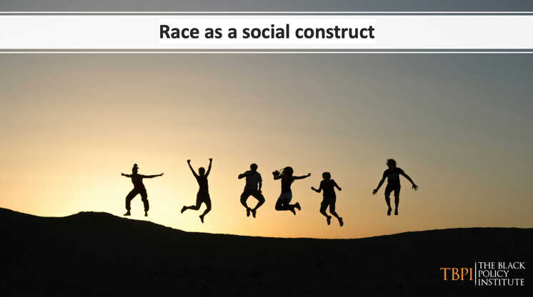

Slide 9: What is Culture?
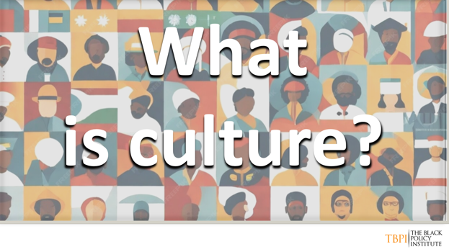

Topic: Understanding Culture
Culture is a dynamic force, not a static entity. It encompasses more than superficial aspects like language, food, music, clothing, and artefacts. While these elements reflect aspects of culture, they are not culture in and of themselves. Rather, culture is a complex amalgamation of moral values, customs, traditions, and practices. It shapes how individuals perceive and respond to the world around them.

For marginalised communities, such as Black people, language can be a double-edged sword. While English may be the dominant language, relying solely on it to define our reality can impose limitations on our understanding. It's essential to recognise that our cultural perspective is broader than any single language or cultural marker.

Validating oneself involves examining how one perceives reality within the cultural context. By acknowledging the multifaceted nature of culture and its influence on our worldview, we can begin to transcend the limitations imposed by dominant cultural norms. This process is crucial for fostering a more inclusive and nuanced understanding of the world.

In essence, culture provides a framework for interpreting reality and a blueprint for living. By embracing our cultural heritage while remaining open to diverse perspectives, we can enrich our understanding of ourselves and the world around us.

Simpler form
Culture is always changing, not staying the same. It's more than just things like language, food, and music. Culture includes moral values, traditions, and how we do things. It shapes how we see and react to the world.

For groups like Black people, language can be tricky. Using only English to describe our lives can limit our understanding. We need to see our culture beyond just language.
Being true to ourselves means understanding how our culture shapes our view of the world. By recognising this, we can break free from limiting ideas and understand the world better.

Culture helps us make sense of things and guides how we live. Embracing our culture while being open to different ideas helps us learn more about ourselves and others.

- How do you think language shapes our understanding of culture and reality?
- Can you identify any ways in which your cultural heritage influences your daily life, including your values, beliefs, and behaviours?
- In what ways do you see cultural diversity celebrated or undervalued in your community or society?
- How might stereotypes or assumptions about culture impact our interactions with others?
- Reflecting on the concept of culture as a "general design for living," how do you think cultural norms and practices evolve over time?
- Have you ever experienced a situation where you felt pressured to conform to cultural norms or expectations that didn't align with your personal values? How did you navigate this experience?
- What role do you think education plays in promoting cultural understanding and appreciation?
- How can individuals actively challenge cultural stereotypes and promote inclusivity in their communities?
- Do you think there's a difference between cultural appropriation and cultural appreciation? If so, what distinguishes the two?
- How might recognizing and valuing diverse cultural perspectives enhance our ability to address global challenges and foster social cohesion?

Slide 10: Mission and Vision
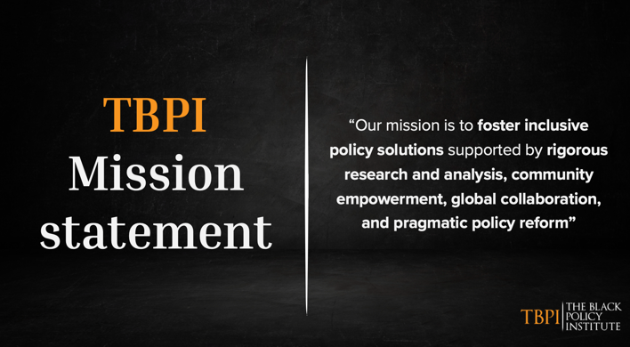
Mission: To advance racial equity, justice, and empowerment for Black communities in the UK and worldwide through rigorous research, coalition building, civic engagement, and ethical technology development.
Vision: A just, equitable and inclusive society where all people can reach their full potential and live with dignity, regardless of race or ethnicity.
- Equal access to opportunity, resources, and power for Black communities
- Empowered local Black communities defining and implementing their own solutions.
- Emerging technologies developed through a racial equity lens to empower rather than oppress.
- Pathways to create Black excellence, brilliance, empowerment, and joy as the norm.

Slide 11/16: Key Pillar of Focus (Mentimeter) Cards (two people to do this part) What is the challenge that we are looking at. Loops back to ‘in order to resolve a problem, one must be able to clearly label it’.

https://www.mentimeter.com/

Key Pillar of Focus
Someone talks about the similarities and differences in the policies that harm Black people in the US and the UK
      - Focus in on policies centred on the Key Pillars
      - Visual Data to show these similarities and differences.
Key Pillars of Focus
Economic Empowerment: Strategies to close racial wealth gaps, enhance equitable Black business ownership and employment, and increase access to funding.
- Black households in the UK have 10 times less wealth compared to white households on average (ref, https://www.jrf.org.uk/uk-poverty-2022-the-essential-guide-to-understanding-poverty-in-the-uk)
Education: Policies to dismantle the school-to-prison pipeline, boost attainment, increase higher ed access, and improve outcomes/representation for Black students and teachers.
- Black students are 3 times more likely to be permanently excluded from school in the UK (https://www.ethnicity-facts-figures.service.gov.uk/education-skills-and-training/absence-and-exclusions/permanent-exclusions/latest/)
Environment: Exploring environmental justice issues disproportionately impacting Black communities like pollution, climate vulnerability, and maternal mortality.
- Black women in the UK are 4 times more likely to die in pregnancy and childbirth compared to white women (ref, https://www.npeu.ox.ac.uk/mbrrace-uk/reports)
Justice: Advocating for policy reforms to policing, sentencing, incarceration, and community investment to eliminate racial disparities in the justice system.
- Black people are 9 times more likely to be stopped and searched by police in England and Wales (ref, https://www.ethnicity-facts-figures.service.gov.uk/crime-justice-and-the-law/policing/stop-and-search/latest/)

 | 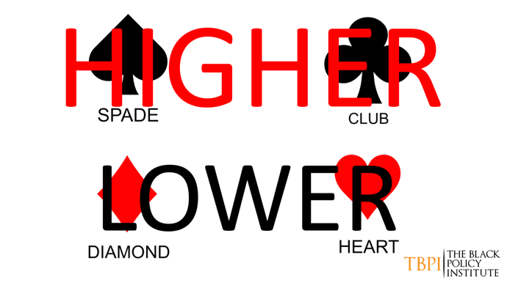
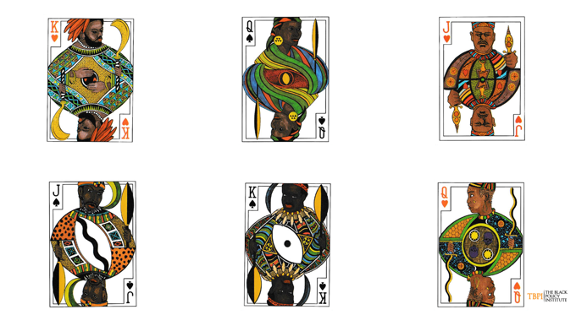 | 
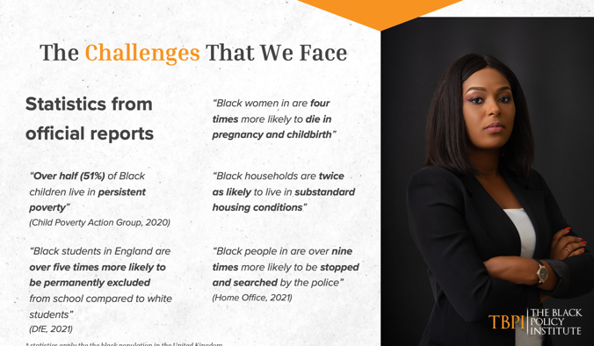 | 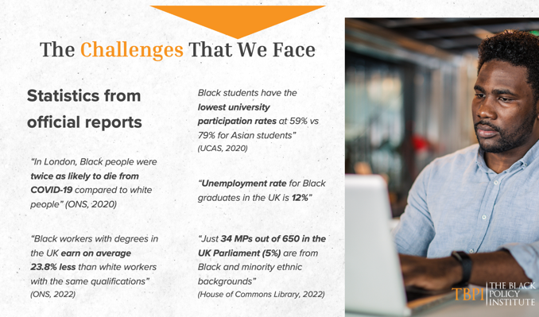

Slide 17/19: Systemic Challenges Require Systemic Solutions
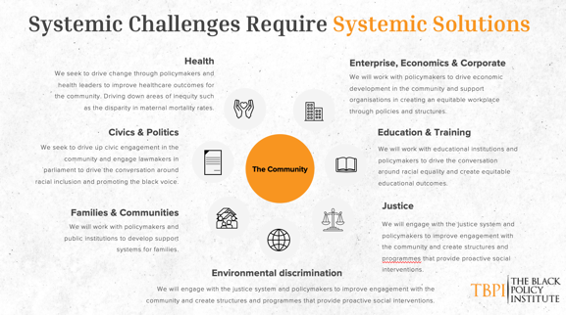
And in this context – those effects everyone by replacing injustices with justice, that serves to elevate all.
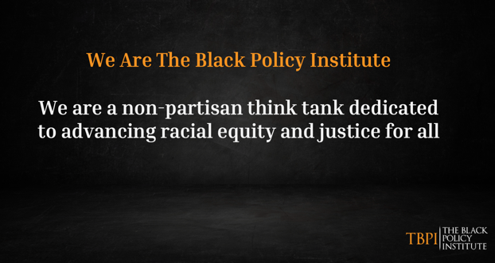 | 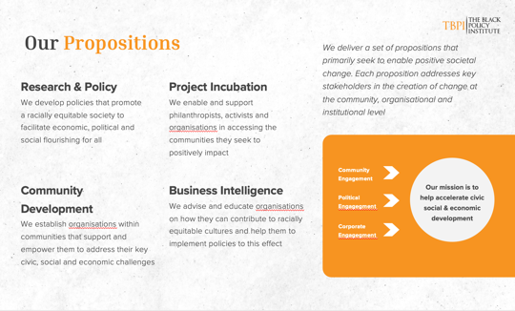

What came out of the project incubation, Podcast – People, Policy, and Power. The Young Peoples Advisory group and the Pioneers of change Programme as a direct need from the communities that we serve to speak to their needs, educate and amplify their voices.
Initiatives for Change
- Research and Policy Analysis: Producing rigorous, community-centred policy reports to inform reform.
- Civic Engagement: Empowering local communities through organising, leadership development, and facilitating feedback loops to drive policy priorities.
- Global Collaboration: Facilitating knowledge-sharing between Black scholars, activists, policymakers, and community leaders in the UK and African diaspora.
- Inclusive Investment: Developing resources to help institutions procure from Black-owned businesses and explore investment models.
- Technology Justice: Researching and advocating for the ethical development of emerging tech like AI to prevent harm and encourage inclusion of Black innovators.

Slide 20: Vision, Ethos UVP, Purpose
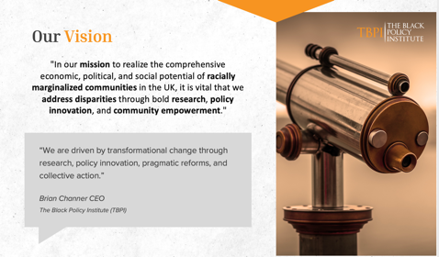 | 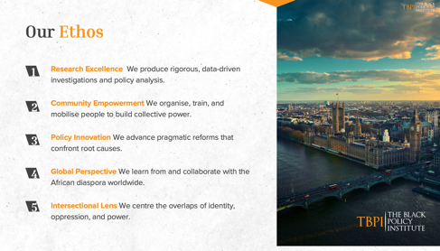
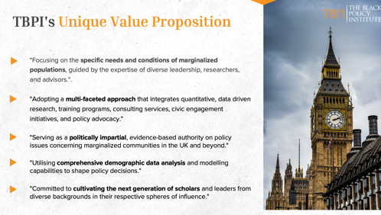 | 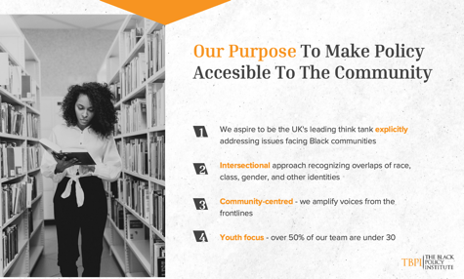

Slide 24/25: Conclusion & and Questions and the emergence of the Elephant
 | 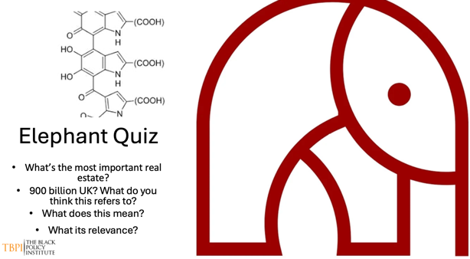

Elephant quiz (time to touch the chair) How many of you have deciphered the puzzle that we have here.
How many have deciphered 1,2,3,4,5?
Ok, let see… speak to the people and see what concepts that they have.
- Race as a Social Construct: Race is a social construct categorizing people based on physical characteristics such as skin colour, hair texture, and facial features. However, it has profound implications beyond mere classification, impacting access to resources, opportunities, and societal perceptions.

- Wealth Inequality and Marginalized Communities: The transfer of £900 billion to the top 1% during COVID-19 highlights the stark wealth inequality within society, disproportionately affecting marginalized communities, including those of different racial backgrounds.

- Genetic Basis of Melanin: Melanin, the pigment responsible for skin colour, is encoded in DNA. Understanding the genetic basis of melanin underscores the biological aspect of race, while also acknowledging the cultural and societal constructs that shape racial identities.

- Elephant Analogy: The analogy of the elephant represents the enormity of the issues surrounding race and wealth inequality. This emphasizes the need to address these systemic issues at both individual and societal levels.

- Quiz Reflections: The quiz prompts participants to critically examine the intersections of race, wealth, and power dynamics. It urges them to recognize the importance of dismantling systemic barriers and fostering equitable opportunities for all individuals, regardless of race or background.

- The Most Important Real Estate Our minds shape our perceptions, beliefs, and actions. By cultivating an informed and empathetic mindset, individuals can challenge prejudices, embrace diversity, and promote equity. The mental space we allocate to understanding and addressing racial and economic disparities is invaluable. It is within this mental realm that transformative ideas and actions towards achieving equity originate.

In considering the critical elements of creating equitable societies, one question stands out: What is the most important real estate? The answer to this is the mind.

In conclusion, by exploring these concepts and reflecting on the questions posed, we can better understand the intricate connections between race, wealth, and societal structures. Recognizing the mind as the most important real estate reinforces the necessity of education, awareness, and intentional efforts to foster equity and justice.

By engaging with these questions and concepts, participants will gain a deeper understanding of the complexities surrounding race and wealth, paving the way for informed discussions and actionable steps towards building a more inclusive and equitable society.

Slide 25: How can you get involved?
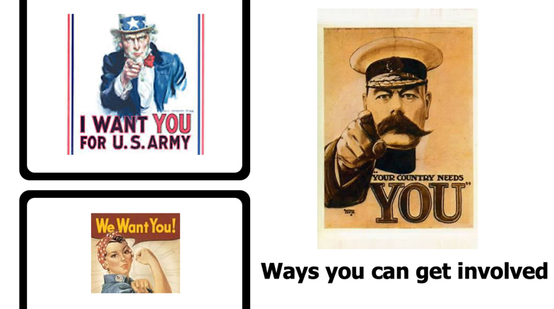
Ways to Get Involved
- How do you see yourselves shaping journalism that shares a narrative influencing the advocacy of implementing more racial and equitable policies positively supporting Black people?
- If you were a think tank, how would you resolve this challenge?

Get Involved
The Black Policy Institute is seeking partners - individuals and organisations committed to racial equity and justice - to help create lasting change. Opportunities include:
- Contributing research, data, and expertise
- Supporting civic engagement and community organising initiatives
- Collaborating on global knowledge-sharing and best practice exchange
- Investing in Black-owned businesses and equitable economic development
- Advocating for ethical technology development and implementation
Join TBPI in this vital work to dismantle systemic inequities and build a more just, inclusive society.

